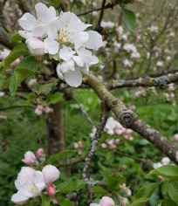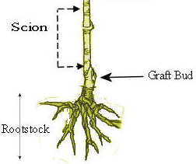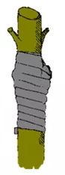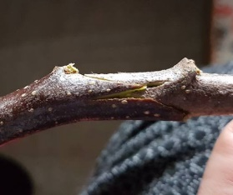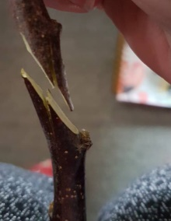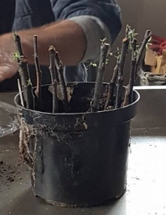

**General Orchard Management**

When planning an orchard think about the slope, aspect, soil, drainage and climate. Be aware of the prevailing wind and also whether or not fencing is needed (to keep animals out) the type of habitat and the wildlife.

Drainage is important. To find out how quickly the water drains away, dig a hole and fill with water.

Soil profile – (soil analysis to find out the types of minerals are there. This isn’t essential but handy to find out. If a soil has less minerals more can be added to make up for the deficiency.

Wind breaks are important if the trees are exposed. A row of willow mixed with different types of trees/shrubs will help slow the wind down before hitting the orchard.

Planting north/south direction means the trees receive more light.

If buying trees order them in advance as the later the year goes on, the more likely you’ll get the ‘dregs’. The earlier they’re ordered the healthier they’ll be.

When designing an orchard have a crab apple tree amongst them (usually 1 to 50 apple trees) as it’ll blossom for longer therefore encourage cross-pollination.

**Rootstock**

If you take a seed from a certain type of apple tree, the product will not be of the same species. Rootstock can be any apple tree (the roots and the shoot) but then the chosen apple species is *grafted* to it (see below). Providing the graft takes the fruit produced will be the same as the original tree it was taken from.

You can buy different rootstocks depending on the size of the tree needed.

M27 is for dwarf trees which are fast growing but has a shorter life.

M106 is for semi-standard trees which are tolerant and a good allrounder.

M25 is for trees with a long-life expectancy, grow tall and vigorous.

**Grafting**

Bind with a flexible material (specialist or improvised – inner tube etc.)

How to graft rootstock to the branch of a desired apple/fruit tree. (There is a device available which cuts quickly although this can be achieved using a sharp knife)

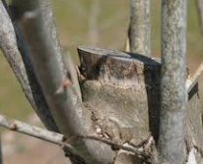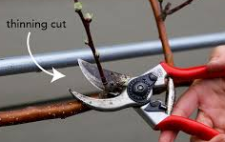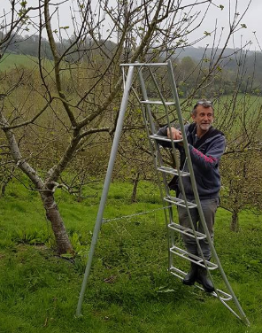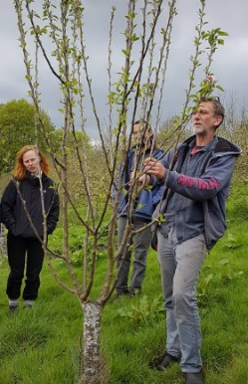

**Pruning**

When pruning it’s important to think about the shape. The thicker the canopy is the less light can enter therefore more likely to be susceptible to disease. Lots of sun, air and wind should be able to enter so pruning inside is necessary.

Winter pruning stimulates growth (young orchards between December and February) and summer suppresses growth (for mature trees).

Pruning should not be done when the tree is in blossom but for the rest of the year pruning won’t harm it.

Less branches = bigger apples.



**First Year**

Cut off branches of a newly planted young tree 30-36 inches from the ground. Make the cut ¼ inch above a good bud at this height. Remove any buds once the petals have dropped (to encourage trunk/branch strength rather than the tree putting energy into fruits).

**Second Year**

Select only three to five healthy, well-spaced branches growing outward in different directions. These will be the main bones of the tree. Remove all others, cutting them flush with the stem again.

**Third Year**

The main branches would have developed lateral branches by now. Remove all but a few healthy, adequately spaced ones per branch.

After the third year, the pruning patterns and seasons may vary between trees. The objective is to help the tree produce fruit in optimum quantity and quality. Trees that are not pruned may have delayed fruit production and in some cases, excessive production of substandard fruit.

**Basic Pruning methods** (<https://garden.lovetoknow.com>)

Remove any dead or diseased branches flush with the main stem they arise from.

Use bench cuts to remove branches that are crossing each other as their constant rubbing can damage the bark and invite infections.

Cut off branches growing into the centre of the tree; they prevent sunlight from reaching the tree centre and reduce air circulation that helps keep away diseases and rot.

Shorten previous year's growth by about one-third to encourage the development of new branches and fruiting spurs.

Trim the main branches when the tree has already reached the desired size.

Trim the side branches leaving only five to six buds on each.

Heading cut thinning cut

* The sharp blade of the secateurs must be positioned to the closest part of tree to ensure a clean cut. If the other side is used the branch may bruise. Clean cuts are important so the wound heals quickly (disease free).

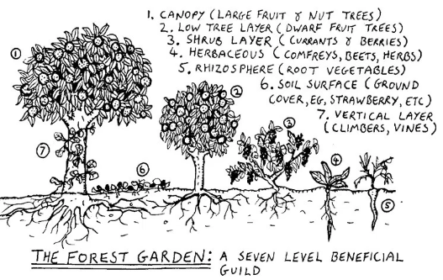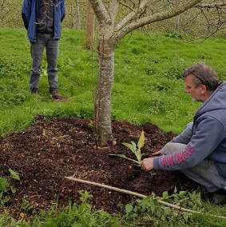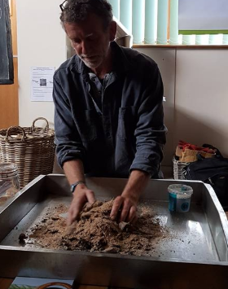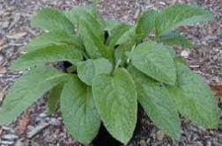

**Companion planting**

Companion planting is where a number of plants are placed together to create a sustainable habitat.

**Creating a Biological fertilizer**

Use semi-rotten leaves (they have good microbes) and add carbon in the form of wheat bran and energy in the form as molasses. (1 leaf mound to 2 heaps of wheat bran – mix together and add molasses).

Pack down in a jar and leave for 30 days. Repeat the process if necessary and then mix with water to create a liquid fertilizer. Spray onto trees (they absorb the microbes which makes them healthy).

**Upkeep and fertilizing an established tree**

Grass around the base of a new tree will take up water therefore in order to give the tree the best start its best to remove grass and then place compost around the base. On top of the compost put down cardboard or a similar biodegradable material and then cover with woodchips. This not only prevents grass returning but will slowly feed the tree.

The root of a comfrey plant is long and draws up nitrogen close to the surface which benefits the tree. Sterile Comfrey ensures that it doesn’t spread and potentially cause problems (Sterile comfrey can be purchased from Ragman’s farm).

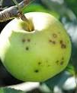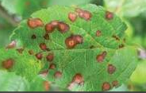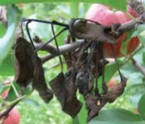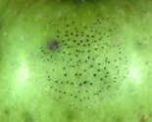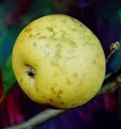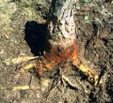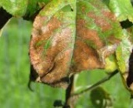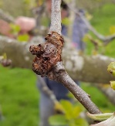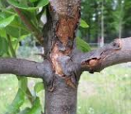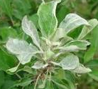

***Cank Apple Scab*** – Apple scab is an apple tree disease that leaves warty, brown bumps on the leaves and fruit. It is a fungus that primarily affects trees in areas that have high humidity.

***Powdery Mildew*** – While powdery mildew affects a great many plants, and on apple trees it can decrease the number of flowers and fruit and cause stunted growth and blemished fruit. Powdery mildew on apples will look like a velvety covering on leaves and branches. It can affect any apple variety, but some varieties are more susceptible than others.  
***Black Rot*** – Black rot apple disease can appear in one or a combination of all three different forms: black fruit rot, frogeye leaf spot, and black rot limb canker.

***Black fruit rot*** – This form of black rot is a blossom end rot, similar to that found in tomatoes. The blossom end of the fruit will turn brown and this brown spot will spread across the whole fruit. Once the whole fruit turns brown, it will then turn black. The fruit stays firm while this occurs.

***Frogeye leaf spot*** – This form of black rot will appear just around the time the blossoms on the apple tree start to fade. It will appear on the leaves and will be grey or light brown spots with a purple edge.

***Black rot limb canker*** – These will appear as depressions on the limbs. As the canker becomes larger, the bark on the center of the canker will begin to peel away. If left untreated, the canker can completely girdle the tree and kill it.

***Apple Rusts*** – The rust that affects apple trees is commonly called cedar apple rust, but it can be found in one of three different forms of rust fungus. These apple rusts are cedar-apple rust, cedar-hawthorn rust and cedar-quince rust.

***Cedar-apple*** rust is the most common. Rust will commonly appear as yellow-orange spots on the leaves, branches and fruit of the apple tree.

***Collar Rot*** – Collar rot is a particularly bad apple tree problem. Initially, it will cause stunted or delayed growth and blossoming, yellowing leaves and leaf drop. Eventually a canker (dying area) will appear at the base of the tree, girdling and killing the tree.

***Sooty Blotch*** – Sooty blotch is a non-lethal but blemishing fungus that affects the fruit of an apple tree. This apple tree disease appears as dusty black or grey spots on the fruit of the tree. While it looks unsightly, the fruit is still edible.

***Flyspeck*** – Like sooty blotch, flyspeck also does not harm the apple tree and only causes cosmetic damage to the fruit. Flyspeck will appear as groups of small black dots on the fruit of the tree.

***Fire Blight*** – One of the more devastating of the apple tree diseases, fire blight is a bacterial disease that affects all parts of the tree and can lead to death. Symptoms of fire blight include die back of branches, leaves and blossoms and depressed areas on the bark that will be discolored and are, in fact, areas of the branches that are dying.  
  
(Taken from Gardening Know How: Information On Common Diseases Of Apple Trees <https://www.gardeningknowhow.com/edible/fruits/apples/apple-tree-diseases.htm>)

**Pests and disease**

.